

Oleider

**Gonzalez**

**Vetancourt**

**Contact:**

*+*55-34614397

[oleidergonzalez11@gmail.com](mailto:oleidergonzalez11@gmail.com)

# Personal data:

Nationality: Venezuelan

Address: Mexico city - Mexico

Date of birth: 01/01/2002

# Language:

Spanish: Native Language

English 80%

# Personal Skills:

Computer systems engineer student with experience over web page building and software maintenance with the ability to adapt to me to new work environment.

# Studies:

Latin Americana Technological University Online - Computer systems engineer student(studying)

Guanare Portuguesa 2013- 2018 administrative service in accounting

# Knowledge technique IT:

*Operating systems over Linux

*Knowledge about database MySQL

*Technical support to computer equipment

*Knowledge languages IT. Python, JavaScript, Html5, Css3

*Libraries

Front-end:

Bootstrap

Vue JS

Back-end:

Flask

*Other knowledge Git & Github

# Job experiences:

•Web page builder (Freelance)

2020-Hoy

*Console Program by handle database MySQL (Freelance)

**Knowledge certificate :**

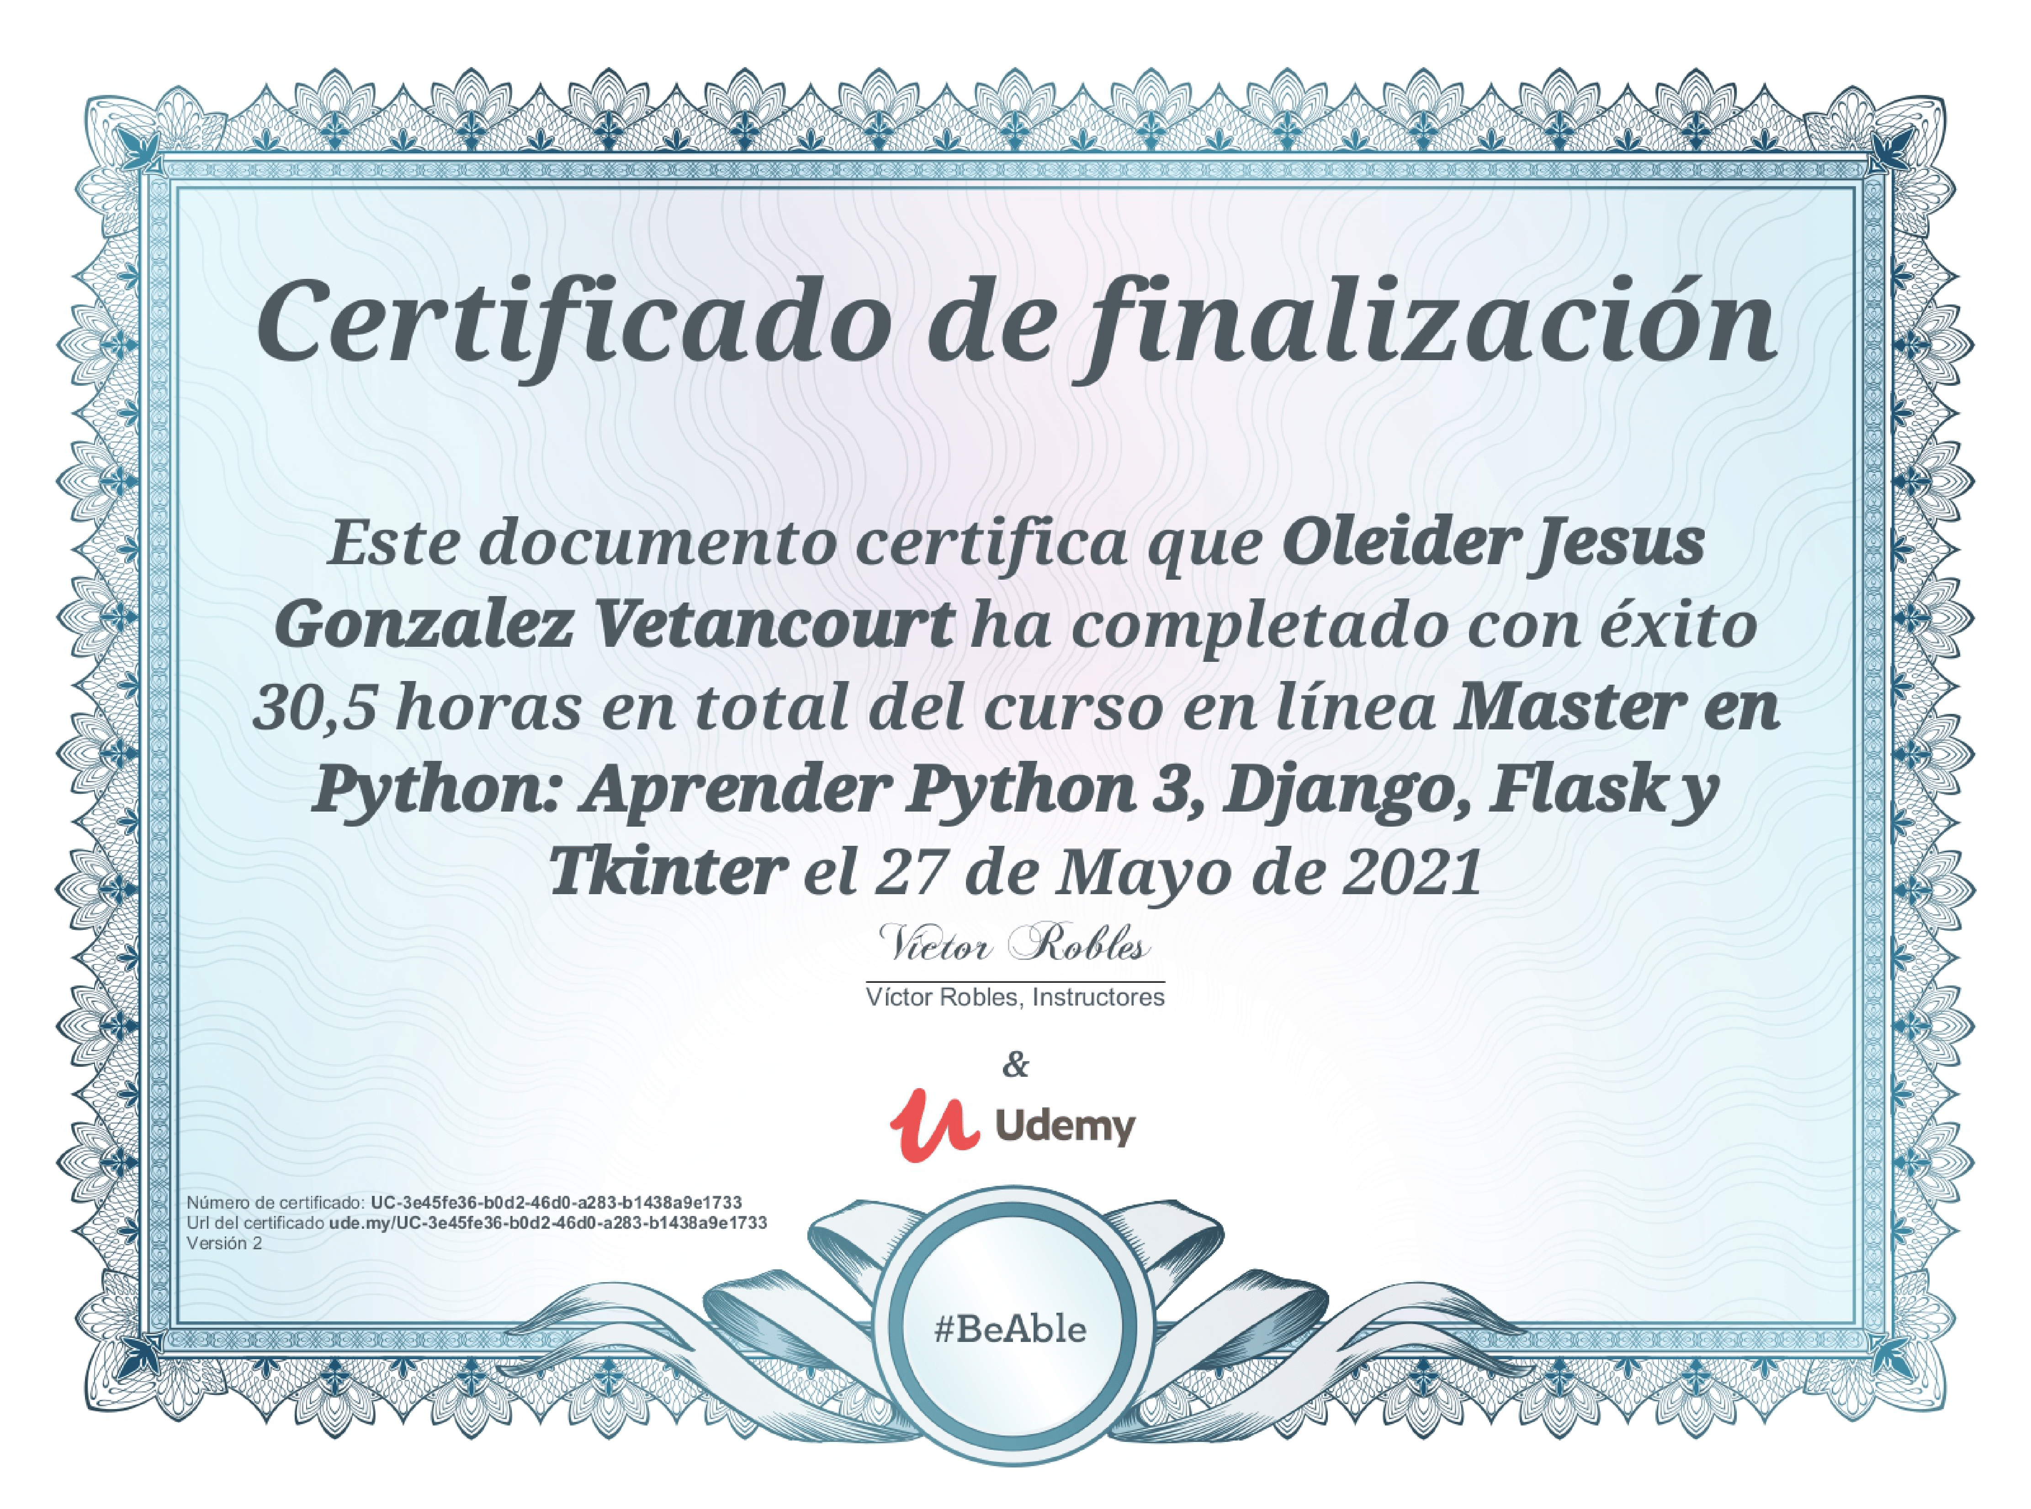

*ATT:*

*Oleider.* J. *Gonzalez Vetancourt*